Ex6 – Create a VPC

# Nithin Prasath C – 22BCS081

## AIM:

To create and configure a Virtual Private Cloud (VPC) in Amazon Web Services (AWS) for secure and isolated networking, enabling efficient management of resources such as EC2 instances and databases within a private network.

## DESCRIPTION:

In this task, we will create a custom Virtual Private Cloud (VPC) in AWS, which allows you to define your own isolated network environment. This includes:

1. **Setting up the VPC** with an IP range (CIDR block).
2. **Creating subnets** for dividing the VPC across availability zones.
3. **Configuring an Internet Gateway** to enable internet access for the VPC.
4. **Setting up route tables** to direct traffic between subnets and the internet.
5. **Configuring security groups** and **network ACLs** to control inbound and outbound traffic for your resources.

This provides a controlled networking environment where instances like EC2 can be deployed securely within private or public subnets.

## OUTPUT:

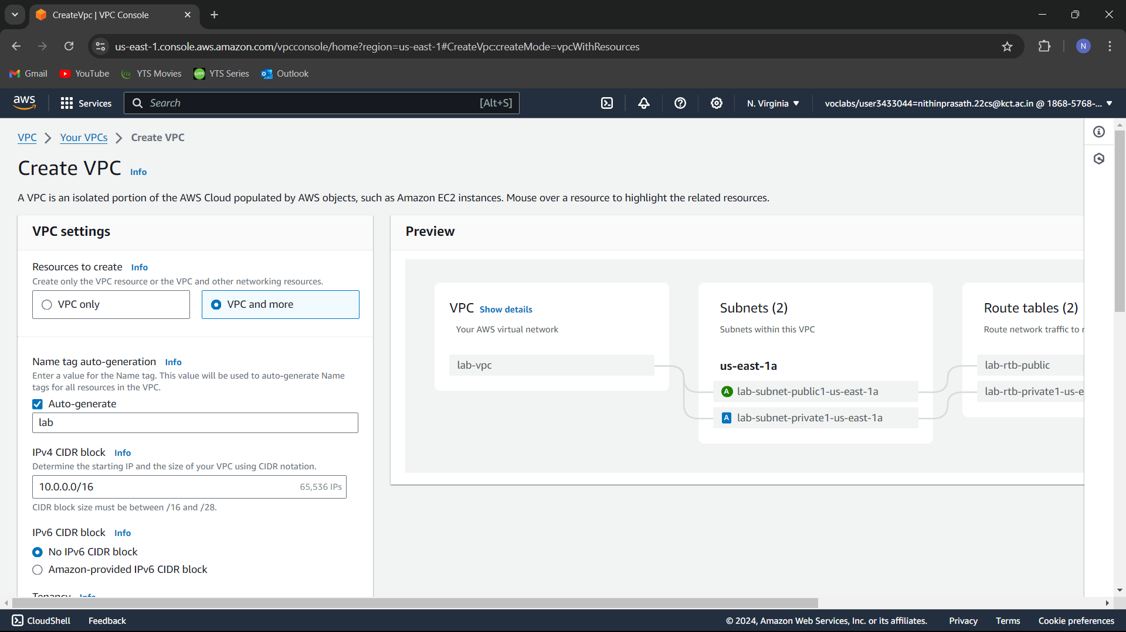

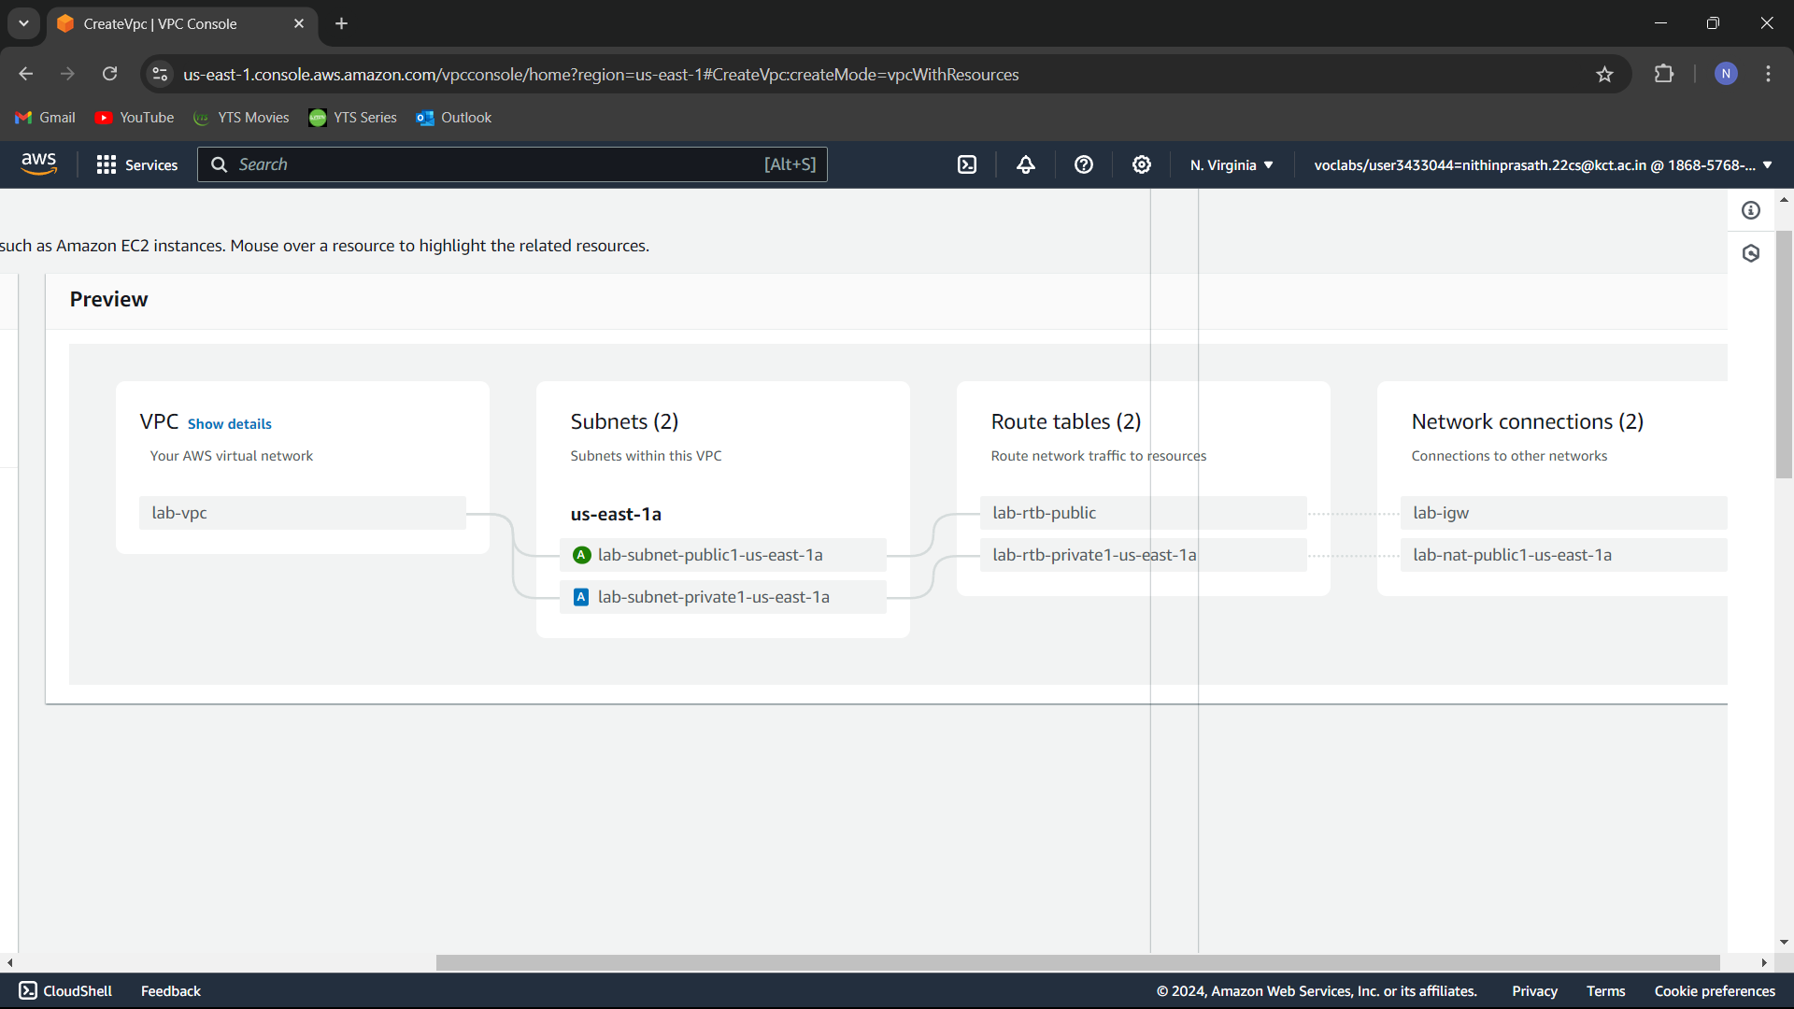

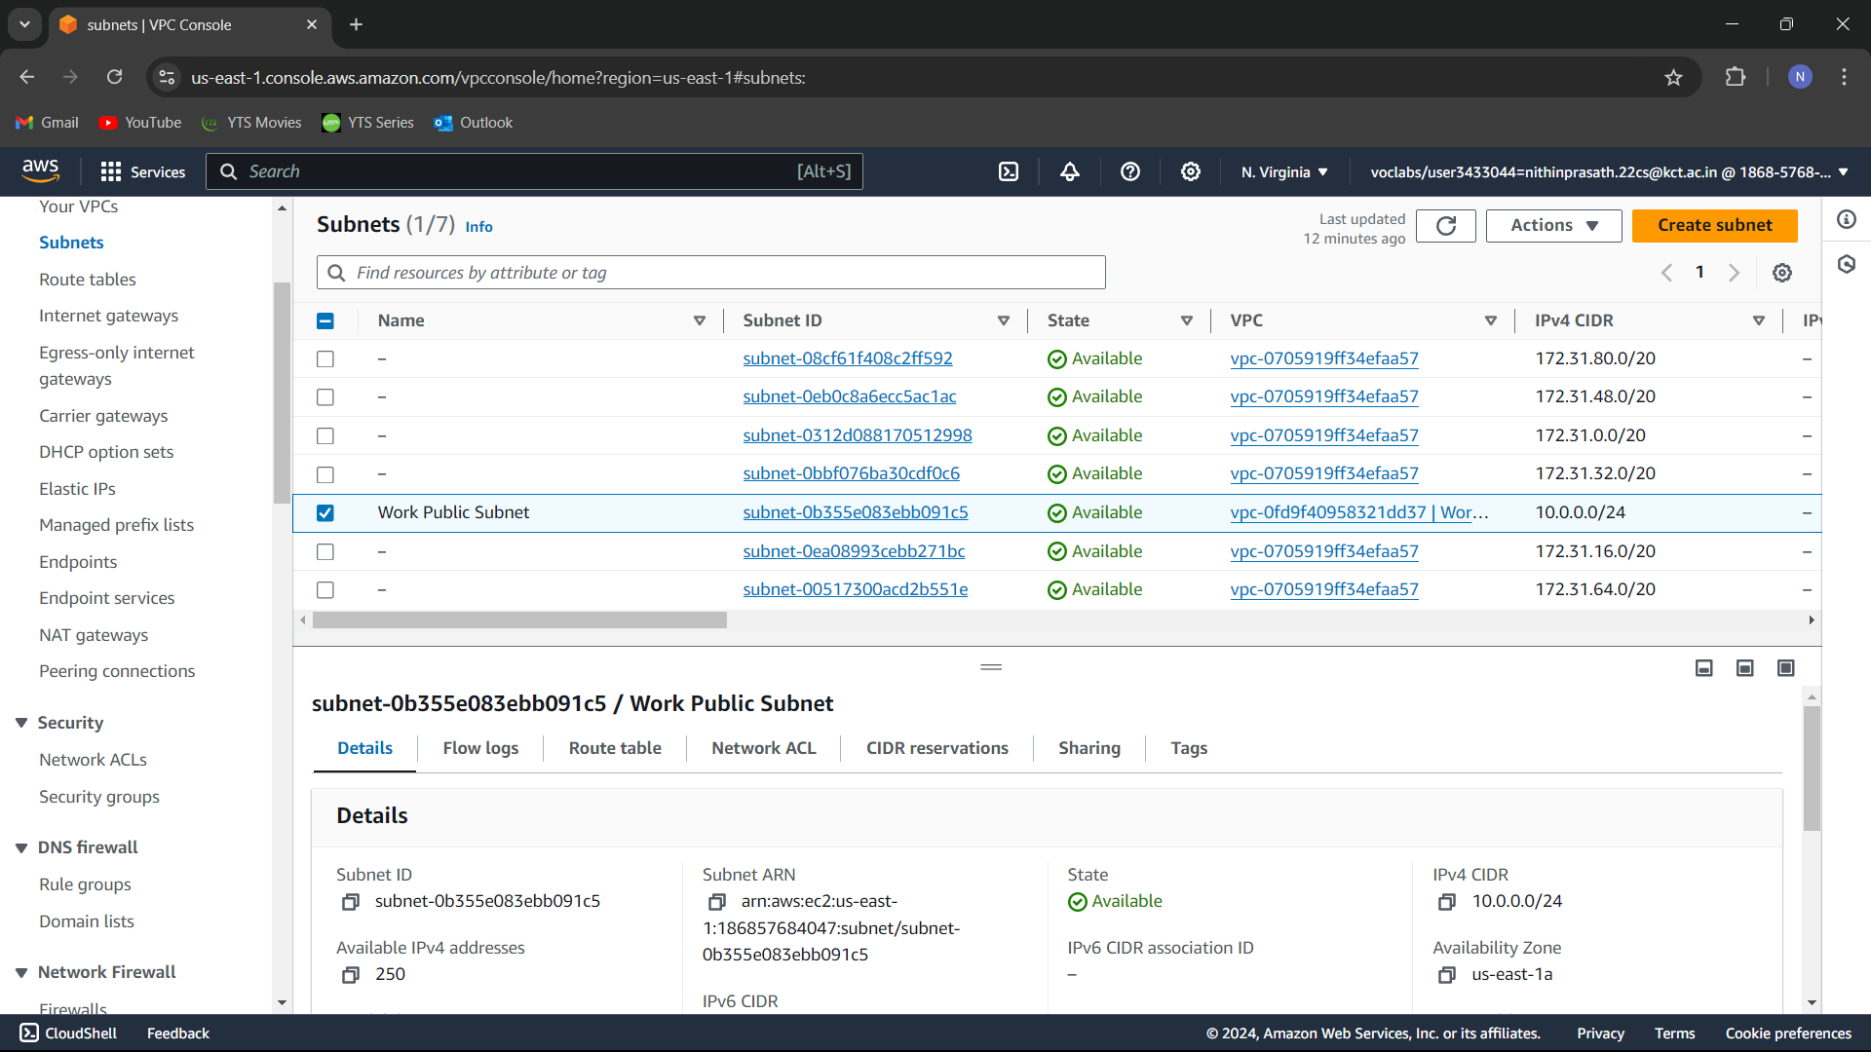

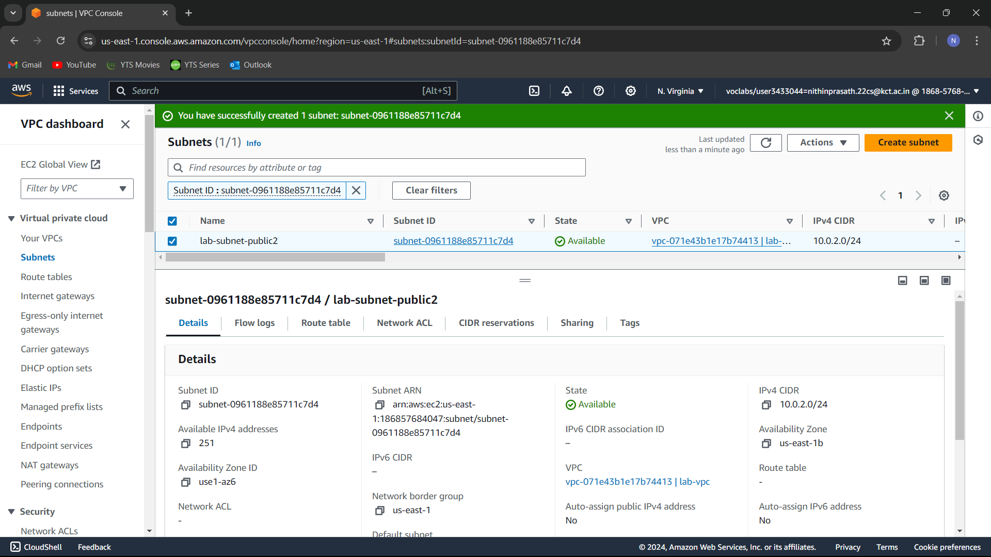

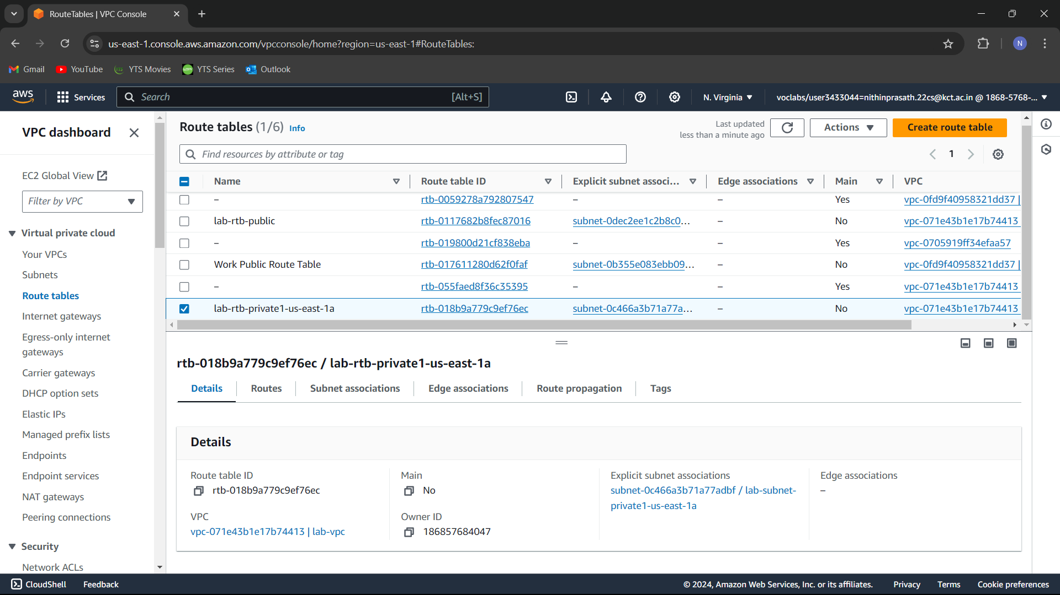

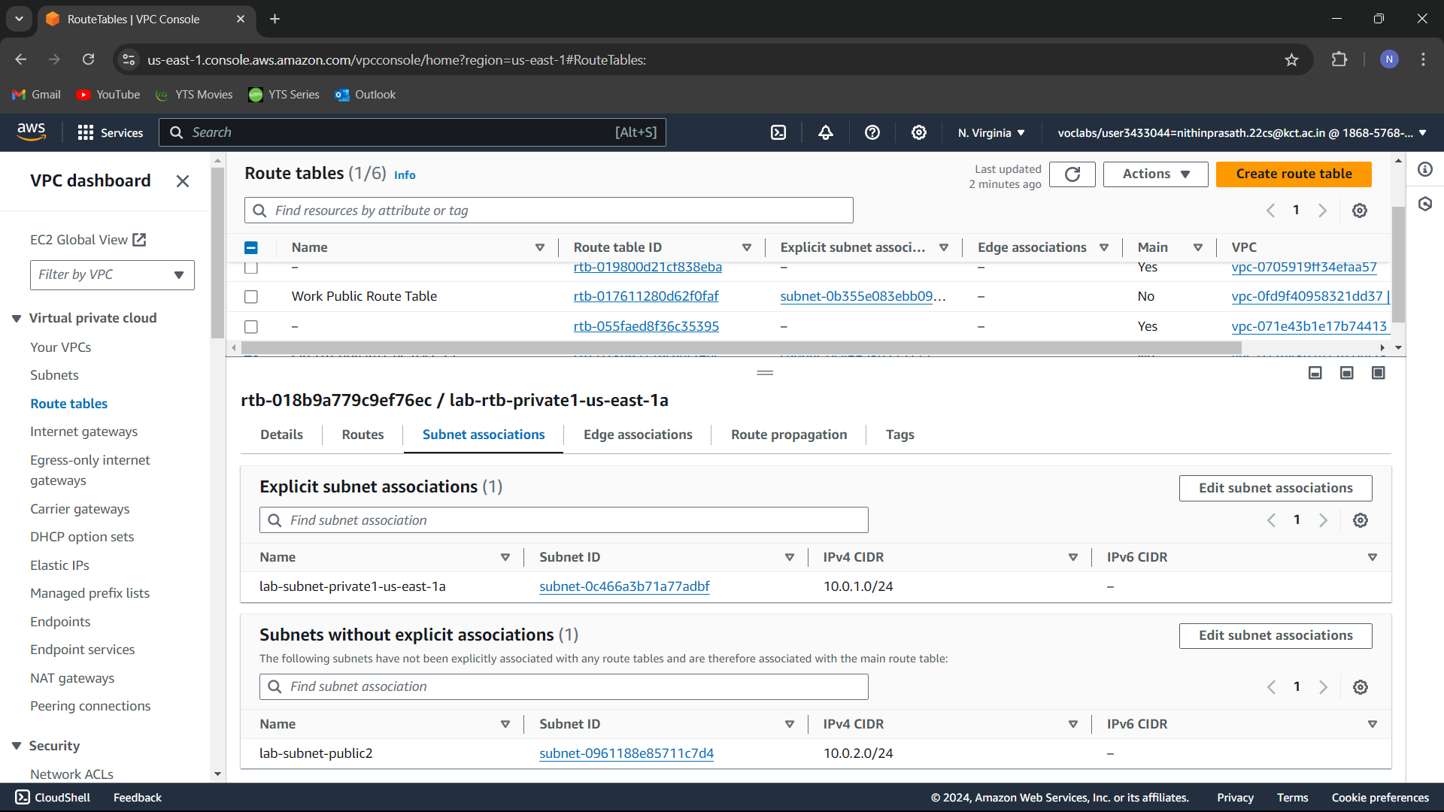

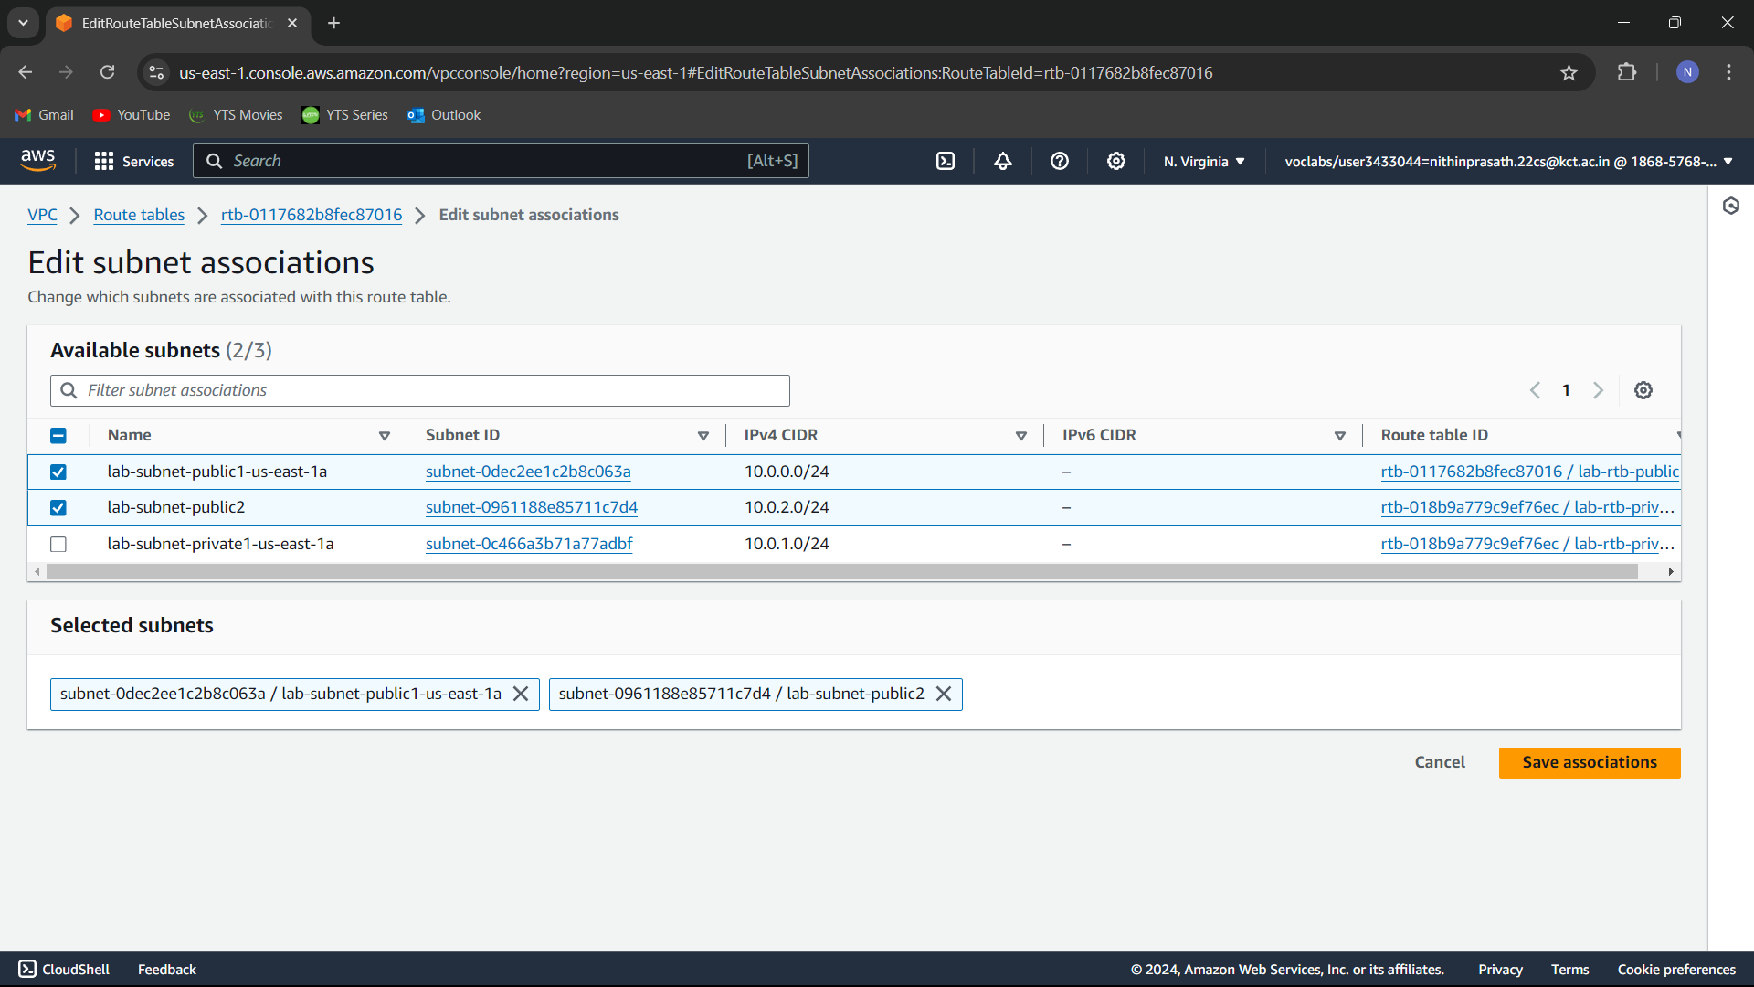

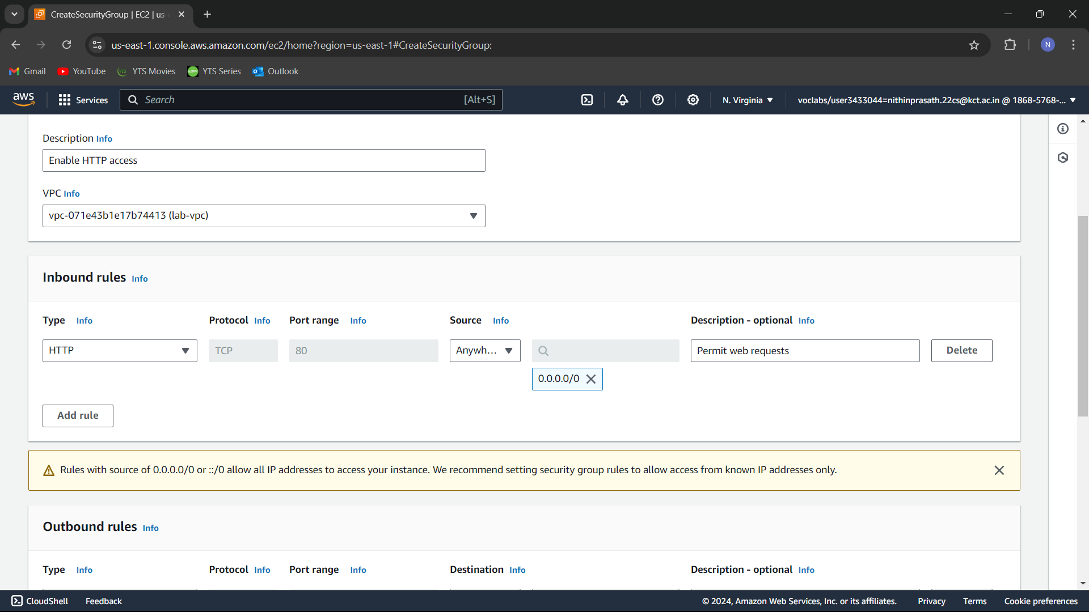

## RESULT:

The VPC is now fully operational and ready to host resources. The instance is now running and accessible. Screenshots are attached to demonstrate each step.